****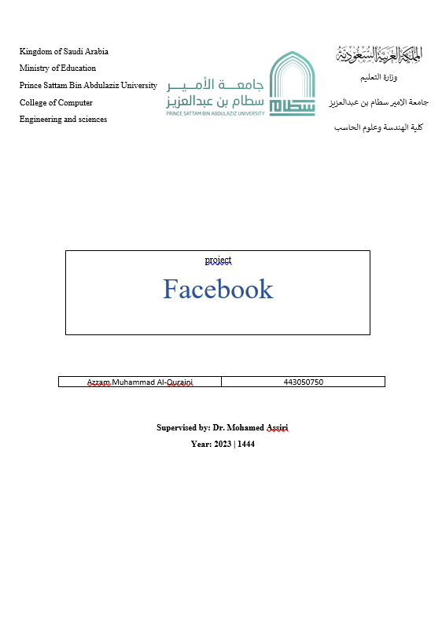

| Project :  HungerStation |
| --- |

| **N** | **Student Name** | **Student Number** |
| --- | --- | --- |
| **1** | **فهد الغامدي** | **443050807** |
| **2** | **عبدالعزيز المديهيم** | **443050845** |

**Supervised by : Dr.Mohamed Assiri**

**Year :1444|2023**

**1.Feasibility Study &Project Proposal.**

**2. Project requirements.**

**3: Activity diagram**

**4: Project Use Case Modelling:**

**5: Creating Sequence Diagrams**

**6: Creating a Class Diagram:**

| **Number** | **Table of Contents** |
| --- | --- |
| 1 | **Introduction** |
| 2 | **Problem Statement** |
| 3 | **Proposed Solution** |
| 4 | **Background** |
| 5 | **Work Plan** |
| 6 | **Functional requirements** |
| 7 | **Non-Functional requirements** |
| 8 | **The flow of most processes** |
| 9 | **Start point / End point / Decision paths** |
| 10 | **Actors** |
| 11 | **Use cases &its related use cases** |
| 12 | **Table 1** |
| 13 | **Table 2** |
| 14 | **Objects** |
| 15 | **Messages** |
| 16 | **Overall** |
| 17 | **Classes attributes + operations** |
| 18 | **Associations** |

1. **Group Project Proposal:**

**A.Introduction:**

**Feasibility Study & Project Proposal:**

At this point, you will conduct a study to determine the feasibility of developing a Hangrytician app.

**Project Requirements:**

You will define requirements for the Hangrytician application based on thorough analysis of the needs of the users, restaurant owners, and delivery team.

**Activities Diagram:**

You will create an activities chart to visualize the workflow and different activities in the Hangrytician app.

**Project Use Case Modeling:**

You will model use cases for a Hangrytician application using techniques such as use case diagrams. You will identify and document various use cases and their associated relationships between actors, systems and processes.

**Creating Sequence Diagrams:**

You will create sequence diagrams to visualize the sequence of messages and interactions

**B.problem :**

1. Some restaurants are far from your area.

2. You must have a car to go to the restaurant.

3. It causes traffic jams and accidents.

**C.Background:**

Established in 2011 in Jeddah, Saudi Arabia, HungerStation has rapidly grown into one of the largest delivery platforms in the world. Hungerstation provides its services in more than 50 countries around the world, and deals with thousands of local and international restaurants.

**D.Proposed solution:**

**Less time:** Instead of going to restaurants and waiting in line, users can order food.

**Convenience and ease:** Hungerstation allows users to browse restaurant menus and choose the items and meals they want easily.

**Variety of options:** Hungerstation deals with a wide range of local and international restaurants, giving users a wide range of food options. No matter what food the user is looking for, they can find it easily through the app.

**Express Delivery:** Hungerstation ensures that food is delivered as quickly as possible. The application coordinates user requests and transfers them to the appropriate restaurant, and the HungerStation team delivers orders quickly and effectively.

**E.Work Plan:**

| **part** | **date** |
| --- | --- |
| **Feasibility Study &Project Proposal** | **28/5** |
| **Project requirements** | **28/5** |
| **Activity diagram** | **1/6** |
| **Project Use Case Modelling** | **1/6** |
| **Creating Sequence Diagrams** | **1/6** |
| **Creating a Class Diagram** | **1/6** |

1. **Project requirements:**

**A.Functional requirements:**

The system will be designed to be user friendly. The user friendly and interactive interfaces design helps to achieve this by enabling customers to easily browse through the menus, view item description, search for items with just a few clicks and also allows system administrator and manager to manipulate the data with minimal delay and confusion.

| **system R** | **UserR** |
| --- | --- |
| The start screen appears with two options (login – create a new account)  When click on create a new account, it asks to enter username, age, phone number,password | Login - Create a new account |
| When click on login, it asks to enter username and password then checks for informati that matches the information entered | Search for the restaurant by name |
| The customer can add a comment about his satisfaction with the system and his rating  a star | Delivery to (KSA - UAE - Qatar - Bahrain - Kuwait - Oman) |
| Interface to edit user profile to update personal information and change password | You can order from a restaurant at the same time |

| **FR** |
| --- |
| **User registration:**  The application should allow users to create a new account and log in using their email or social media accounts.  An interface should be provided to edit the user's profile to update personal information and manage notifications. |
| **Browse restaurant menus:**  The list of available restaurants should be displayed with their basic information such as address, rating and rating.  Users shall be able to search for restaurants and browse their menus by type, location, food ratings, and other criteria. |
| **Food order:**  Users must be able to select the required meals and add them to their shopping cart.  An interface should be provided for specifying portion sizes and adding special notes. |
| **Cart management and orders:**  Users must be able to view and modify the items in their shopping cart.  Users should be given an option to delete items or modify quantities. |
| **Payment procedure:**  It should provide an interface for safe and easy payment for users.  Several payment methods must be supported, such as credit cards, PayPal, and others. |
| **order tracking:**  Users should be able to track the status of the order and know its current location and remaining time for delivery. |
| **Ratings and Reviews:**  Users shall have the ability to rate and provide feedback on their dining experience, including food quality, delivery service, and overall satisfaction.  The app should display average ratings and reviews for each restaurant, helping users to make informed decisions. |
| **Customer Support:**  The application should provide a customer support feature, allowing users to contact customer service for any inquiries, complaints, or assistance.  Users should have access to a support chat or a helpline number within the application. |

**B.Requirements are not functional:**

| **FNR** |
| --- |
| **Reliability:**  The system should be reliable, that is it can carry its specific operations under all conditions. |
| **Security:**  The system must be secure, allowing only authorized users to access information.  **To verify the password, it must consist of 8 digits consisting of (uppercase letter - lowercase letter - numbers - @ sign - $ sign.** |
| **Speed:** The system should be able to process transactions in good time. |
| **Usability: The system should be easy to use such that the user should gain competency in the use of the system with minimal training.** |
| **Offline order:**  The application does not need to support offline ordering or allow users to place orders when they are not online. |
| **Reservations schedule:**  The app does not need to include a feature for users to book tables at restaurants. Focuses only on online food ordering and delivery. |
| **Integration with external payment systems:**  The application does not need to integrate with specific third-party payment systems or .support dedicated payment gateways. |
| **Send a verification code via email or phone numbe.** |
| **Availability:** The site is available for use within 24 hours and 7 day. |
| **Reliability :**The site failure rate is 0.1% . |
| **Maintainability:**The site is always updated if new technologies are found. |
| **Robustness:**When you fail to pay due to the failure of the site, your order will be deleted and you will have to return it again . |

**3: Activity diagram :**

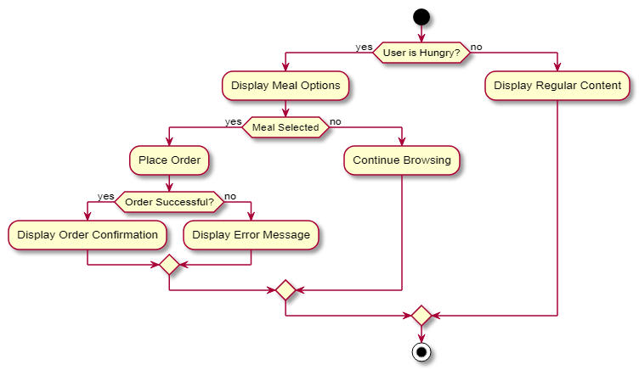

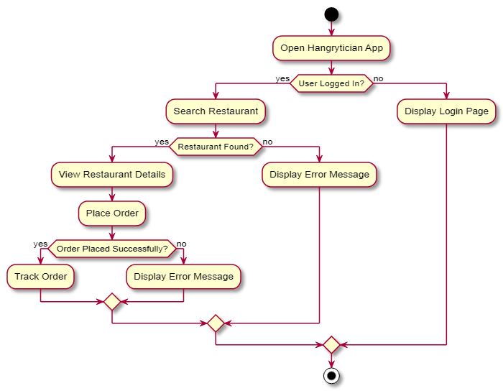

**4: Project Use Case Modelling:**

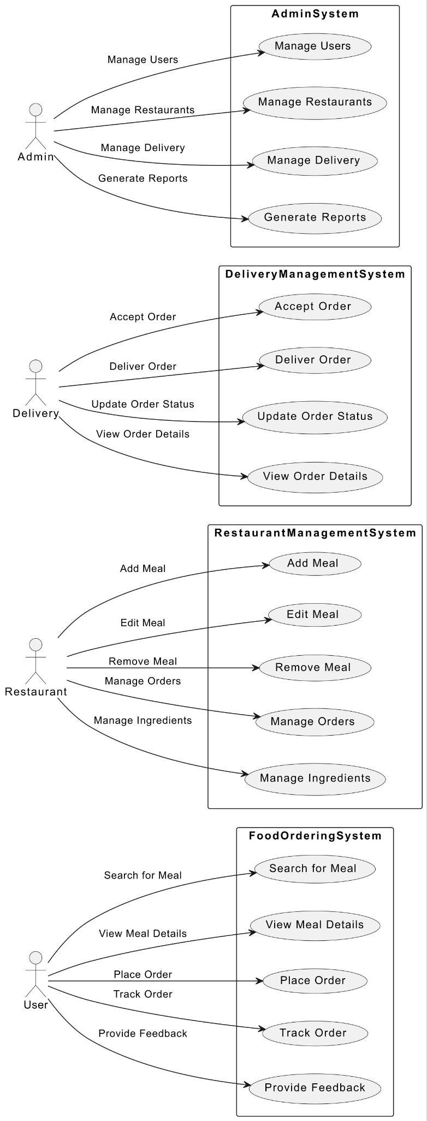

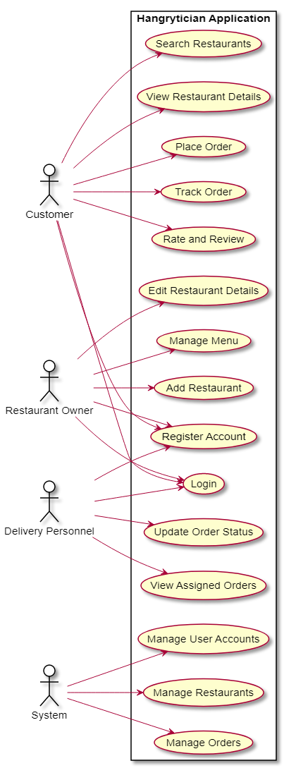

**Table 1 :**

| **Actors:** | **user** |
| --- | --- |
| **Input:** | Submit a request to the restaurant |
| **Output:** | Administrator approval - View schedule to feed |
| **Normal operation:** | The user submits a request and inserts notes for his request. Then the restaurant accepts or rejects his request, and if the restaurant's request is accepted, his request and notes are displayed, and the request is prepared and sent |

**Table 2 :**

| **Actors** | admin |
| --- | --- |
| **Input:** | Adds new dishes to the site and registers on the databases |
| **Output:** | It appears to the user on the site and he can order it |

**5: Creating Sequence Diagrams :**

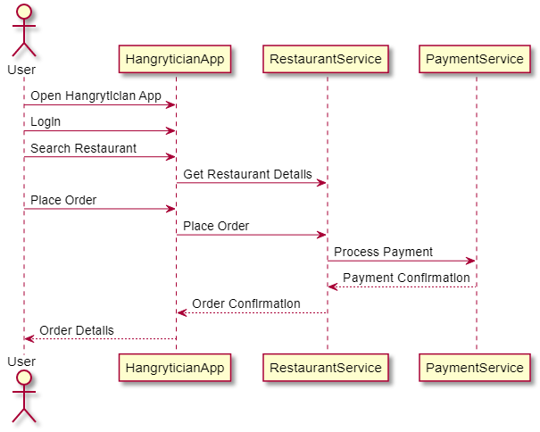

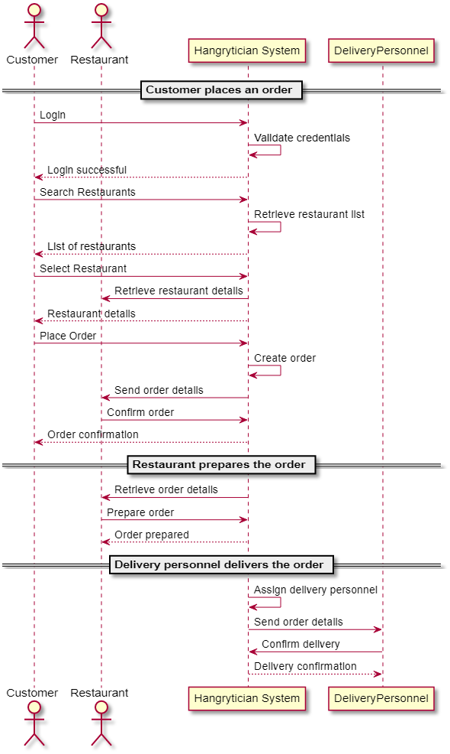

**6.Creating a Class Diagram:**

